

Sagility

Assessment Control
Integration Guide


Technical Specification
September 10, 2026

Version Information
Version | Date | Author | Changes
1.0 | 2026.09.10 | Jody McGuire | Initial draft.
1.0 | 2026.09.11 | Jody McGuire | Initial draft complete.

Contents
1. Background 4
2. Functional Overview 5
3. Assessment Tester Application 5
3.1. User Interface 5
3.1.1. Assessment Tester Input Fields 6
3.1.2. Assessment Start 7
4. Assessment Control Integration 7
4.1.1. Properties 7
4.1.2. Events 8
4.1.3. UI Styling 8
5. E24 Proxy Layer 9
5.1. E24ProxyController API 9
5.1.1. Controller Overview 9
5.1.2. Public Endpoints 9
6. Assessment Execution Lifecycle 11
7. Assessment Component Updates 12

Background
There exists the need to be able to provide a member with the capability to perform an online assessment related to the member’s health situation.
Delivery of assessments is currently utilized for various Sagility applications including AIP and Utilization Management (UM).
This document will describe how to integrate and utilize the new Assessment Control in an Angular application, as well as the internal architectural aspects of assessment delivery.

Functional Overview
The assessment capability utilizes a partner Expert 24 to build and deliver assessments. Expert 24 is physically located in England and exposes capabilities to create and execute assessments in the cloud.

Project Locations

Product Repo
Assessment Control: (dev_standalone) /source/Components/ClinicalContent/AssessmentControl

Clinical Content Service: (dev_standalone) /source/Components/ClinicalContent/ContentService

Assessment Tester Application

User Interface
A fully functional assessment tester application has been created, providing guidance for integrating the Assessment Control into an Angular application.
The following image is the user interface for the tester application and includes a set of user input fields. The values in the fields are used to successfully initialize and present an assessment’s first question, allowing the user to navigate the questions one by one until the end of the assessment is reached.
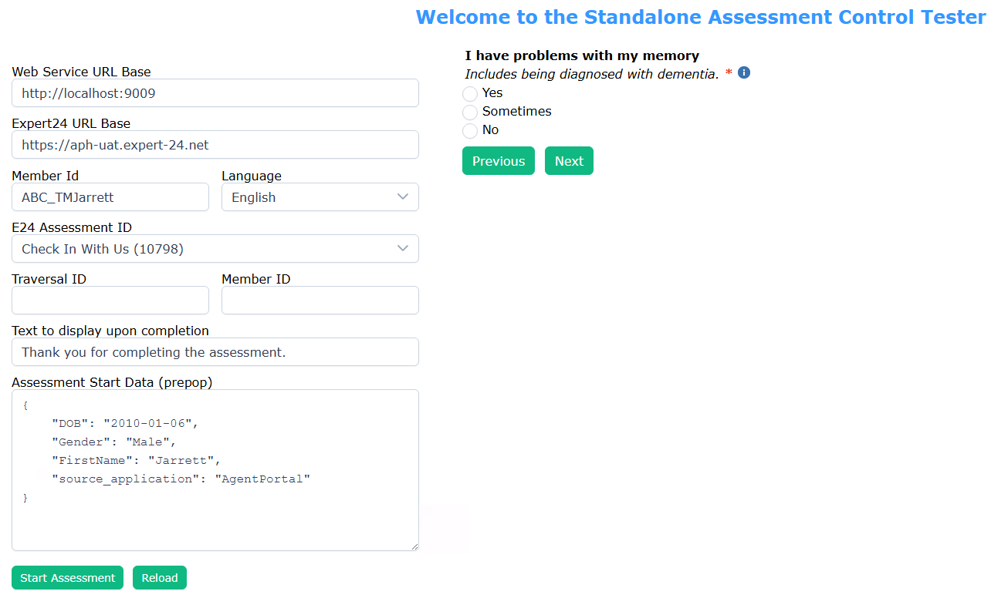
Upon successful completion of the assessment, a text area will appear containing the final data summary for the assessment that includes the questions answered, any outcomes established via the answered questions, and any care plan items as determined by the answered questions.
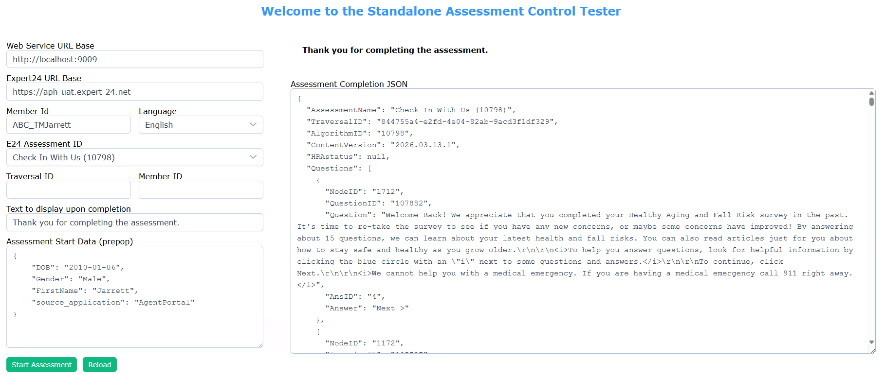

Assessment Tester Input Fields
Web Service URL Base – The base URL for the Clinical Content Service instance that will act as a proxy to the Expert24 cloud-based APIs. The URL should be very similar to the value presented in the image above, with the server’s name and port number being the only values that are different. Once pointed at a production URL, the http would be replaced with https if the route between the two endpoints is to be encrypted.
Expert24 URL Base – The base URL for the Expert24 cloud-based APIs. Note that in Expert24 each environment (authoring, QA, UAT, Production) have their own URL, so specify your value with care.
Member Id – The id of the member for which the assessment will be performed. The value specified must exist in the Web Service URL identified target environment.
Language – Set to English.
E24 Assessment ID – The numeric algo id for the assessment as it exists within Expert24.
Traversal ID – The id for the assessment execution instance as returned by Expert24 at assessment initialization. This value is important when going to CONTINUE a prior unfinished assessment.
Member ID – The numeric member id for the supplied member as generated and returned by Expert24 at assessment initialization. This value is important when going to CONTINUE a prior unfinished assessment.
Text to display upon completion – Optional text to be displayed when the assessment is completed.
Assessment Start Data (prepop) – Each assessment when defined by the clinical content team can require and support a unique set of data inputs that are utilized in the navigation of the assessment by the Expert24 internal rule engine at execution time. In this field, provide a JSON defined set of key/value pairs for each required prepop parameter.

Assessment Start
Once you have provided values for all supplied input fields, you can begin the specified assessment by clicking the Start Assessment button. Once the button is clicked, the demo application will pass the supplied values to the Assessment Control, initializing the assessment instance within Expert24, and then will retrieve the first question in the assessment and present it to the user.
To navigate the questions of the assessment, provide an answer to each presented question and select the Next button to navigate to the next question in the assessment. Clicking the Previous button will return the user to the assessment’s previous question. Once all questions have been answered the assessment will present to the user a message informing them that the assessment is complete.
See the next section for information on how to set a custom assessment finalization message via the assessmentCompletedLabel property.
See the appendix for guidance on updating to a new version of the Assessment Control.

Assessment Control Integration
The Assessment Control exposes a set of properties that can be set to configure the control and exposes a set of events that can be implemented for awareness of control activities.

Properties
The following properties are defined for the Assessment Control:
memberId - The id of the member for which the assessment will be performed. The value specified must exist in the Web Service URL identified target environment.
webserviceUrlBase – The base URL for the Clinical Content Service instance that will act as a proxy to the Expert24 cloud-based APIs. The URL should be very similar to the value presented in the image above, with the server’s name and port number being the only values that are different. Once pointed at a production URL, the http would be replaced with https if the route between the two endpoints is to be encrypted.
e24UrlBase – The base URL for the Expert24 cloud-based APIs. Note that in Expert24 each environment (authoring, QA, UAT, Production) have their own URL, so specify your value with care.
language – Set to English (eng).
assessmentAlgorithmId – The numeric algo id for the assessment as it exists within Expert24.
e24TraversalId – The id for the assessment execution instance as returned by Expert24 at assessment initialization. This value is important when going to CONTINUE a prior unfinished assessment.
e24MemberId – The numeric member id for the supplied member as generated and returned by Expert24 at assessment initialization. This value is important when going to CONTINUE a prior unfinished assessment.
assessmentCompletedLabel – The message to display at the end of the assessment. If not provided, a default message letting the member know that <assessment name> has been completed will be displayed.
assessmentName – The name of the assessment to be included in the display of the assessment completion message.
assessmentStartPrepop – Each assessment when defined by the clinical content team can require and support a unique set of data inputs that are utilized in the navigation of the assessment by the Expert24 internal rule engine at execution time. In this field, provide a JSON defined set of key/value pairs for each required prepop parameter.

Events
The following events are defined for the Assessment Control.
assessmentIsComplete – Exposes the fact that the assessment is complete.
assessmentTraversalIdSet – Exposes the fact that the assessment is started.
assessmentErrorOccurred – Exposes error information.

UI Styling
The Assessment Control has been setup so that it will utilize the packages and styles as defined in the parent project of the control. See the demo application for reference in how to setup the Assessment Control for successful integration into your application.
The default style for the Assessment Control has been set to the style that you can see in the demo application UI image earlier in this document. Of note are the following CSS attributes defined in the theme.css file.
@charset "UTF-8";
:root {
--text-color:#000001;
--text-color-secondary:textSecondaryColor;
--primary-color:#0073e6;
--primary-color-text:#ffffff;
--primary-color-hover:#0066cc;
--primary-color-active:#0066cc;
--primary-color-focus:#0066cc;
--font-family:Arial, Verdana, sans-serif;
--font-size:.85rem;
--letter-spacing: .05em;
}

While you can adjust the theme file to your desires, the variables defined above control the major appearance items of the UI such as font size and font family.

E24 Proxy Layer

E24ProxyController API

Controller Overview
The E24ProxyController implements a communication abstraction between the UI Assessment control and the Expert24 cloud APIs. While it is used by the Assessment control, it also provides the ability for other implementations of assessment delivery to occur, such as providing phone/AI based assessment delivery.

Base route: api/E24Proxy
Purpose: Proxies client requests to Expert24 traversal APIs.
All endpoints require query parameter: expert24urlBase
Responses preserve upstream status code, response body, and content type.

Public Endpoints

Start Assessment
Starts an Expert24 assessment as a new assessment.
Method/Route: POST api/E24Proxy/start
Query: expert24urlBase (required)
Body: memberId (string, required), prepop (object, optional) (see Prepop section for details)
Upstream: POST expert24urlBase/webbuilder/TraversalService/Member
Upstream payload:

{
"memberId": "string",
"prepop": [
"string"
]
}

2) Begin-Continue
Sets up an assessment for continuance of an existing incomplete Expert24 assessment.
Method/Route: POST api/E24Proxy/begin-continue/traversalId/e24MemberId
Route params: traversalId (string), e24MemberId (string)
Query: expert24urlBase (required)
Body: memberId (string, required), prepop (object, optional)
Upstream: POST expert24urlBase/webbuilder/TraversalService/Prepop/traversalId/e24MemberId
Upstream payload:

{
"memberId": "string",
"prepop": [
"string"
]
}

3) Continue
Continue an existing incomplete Expert24 assessment.
Method/Route: GET api/E24Proxy/continue/traversalId/e24MemberId
Route params: traversalId (string), e24MemberId (string)
Query: expert24urlBase (required)
Upstream: GET expert24urlBase/webbuilder/TraversalService/GoBack/traversalId/e24MemberId/0/-1

4) First
Get the first question for an assessment.
Method/Route: POST api/E24Proxy/first/traversalId/e24MemberId/algorithmId
Route params: traversalId (string), e24MemberId (string), algorithmId (string)
Query: expert24urlBase (required), language (optional)
Language normalization: spa/spanish -> SPANISH; eng ->English; otherwise MEMBER.
Upstream: POST
expert24urlBase/webbuilder/TraversalService/First/traversalId/e24MemberId/algorithmId/0?Language=MEMBER|SPANISH

5) Next
Get the next question for an assessment.
Method/Route: POST api/E24Proxy/next/traversalId/e24MemberId/algorithmId/previousNodeId
Route params: traversalId (string), e24MemberId (string), algorithmId (string), previousNodeId (int)
Query: expert24urlBase (required)
Body: arbitrary JSON (optional; defaults to )
Upstream: POST
expert24urlBase/webbuilder/TraversalService/Next/traversalId/e24MemberId/algorithmId/previousNodeId

6) Previous
Get the previous question for an assessment.
Method/Route: GET api/E24Proxy/previous/traversalId
Route param: traversalId (string)
Query: expert24urlBase (required)
Upstream: GET expert24urlBase/webbuilder/TraversalService/Previous/traversalId

7) Info
Get the informational (tooltip) text for a question or answer.
Method/Route: GET api/E24Proxy/info/traversalId/noteType/itemId
Route params: traversalId (string), noteType (int), itemId (int)
Query: expert24urlBase (required)
Upstream: GET expert24urlBase/webbuilder/TraversalService/Info/traversalId/noteType/itemId

8) QA
Get the final set of a data for a completed assessment. It includes the questions and answers as well as any outcome recommendations or care plan items.
Method/Route: GET api/E24Proxy/qa/traversalId
Route param: traversalId (string)
Query: expert24urlBase (required)
Upstream: GET expert24urlBase/webbuilder/TraversalService/QA/traversalId

Consumer Notes
Pass a fully qualified expert24urlBase value, including scheme (for example, https://...).

Use environment-specific base URLs for development, QA, UAT, or production.

Assessment Execution Lifecycle
The following image describes the operations that occur when initiating and performing an assessment, with clear delineation of the operations that are provided by the Expert24 cloud-based assessment service.
The Consuming Application would be your Angular application. In it you would embed the Assessment Control and supply it with the required set of input values to successfully instantiate and utilize the control.
The Consuming Application component initializes the Assessment Control with a set of inputs that initialize the control with the metadata needed for it to load the specified assessment.
Once the assessment has been initialized, the user or member interacting with your application will be presented with the first question in the assessment. As the member supplies answers to the individual questions and selects the Next button, the member will be presented with the next question in the assessment until the end of the assessment has been reached.
Once the end of the assessment has been reached a final set of data will be returned that contains the answered questions, any outcome recommendations, and any care plan items.

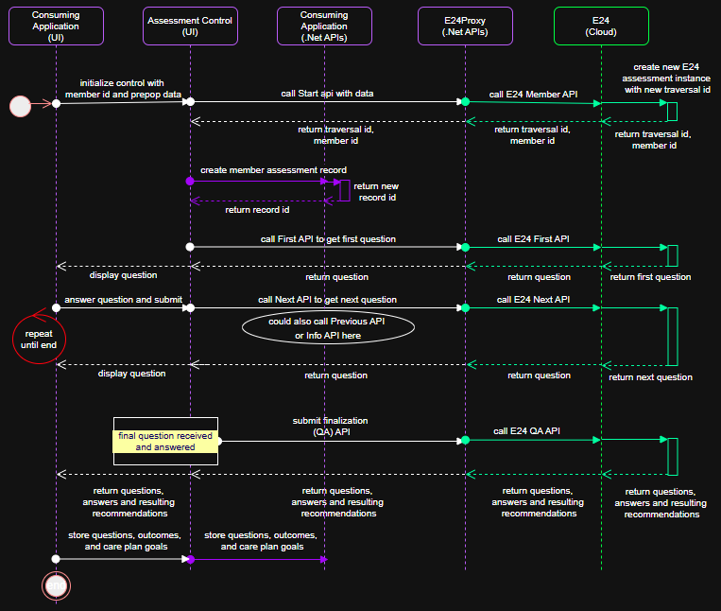

Assessment Component Updates
As new versions of the Assessment Control are produced over time, it will be necessary to update your Consuming Application application/component to utilize the new version of the Assessment Control. See the file README.md in the Assessment Control project for further guidance.
A new instance of the Assessment Control zip file will be named in the following format: assessment-ctrl-0.0.1.tgz and would need to be updated in your consuming application.

